1553 NW Ballard Way, Seattle, WA 98107 | La Marzocco  Marco  Mazzer | Phone: 206.706.9104  Fax: 206.706.9106  Web: www.lamarzoccousa.com

LA MARZOCCO TECHNICAL BULLETIN #92

Anti-Suction Valve for Strada EP

Dear La Marzocco family members,

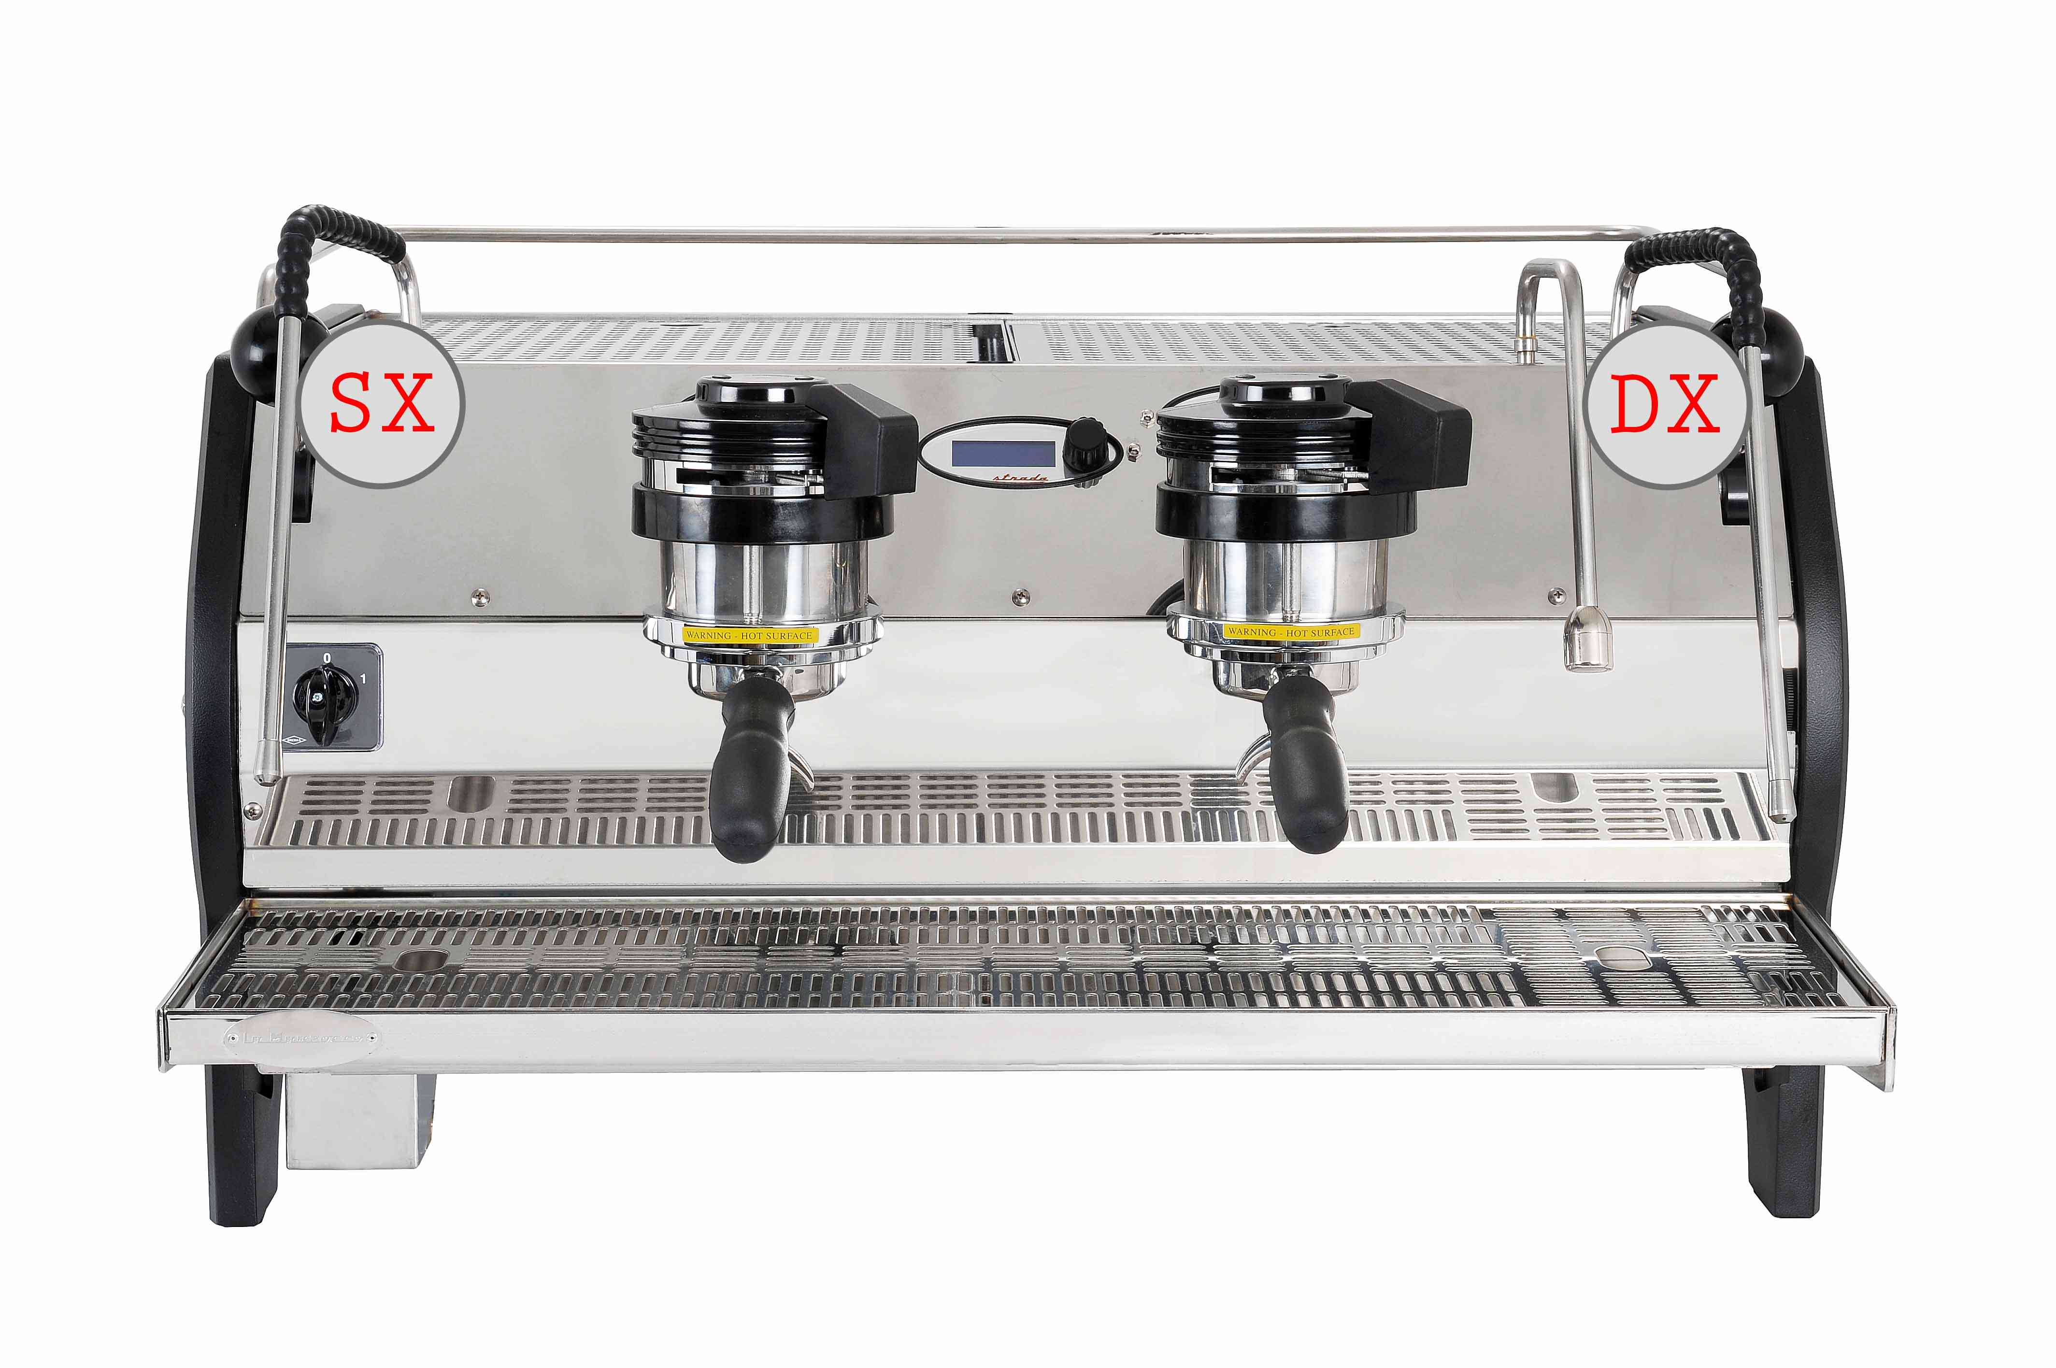
We would like to introduce you to the Anti-suction Valve on the Strada EP steam system.

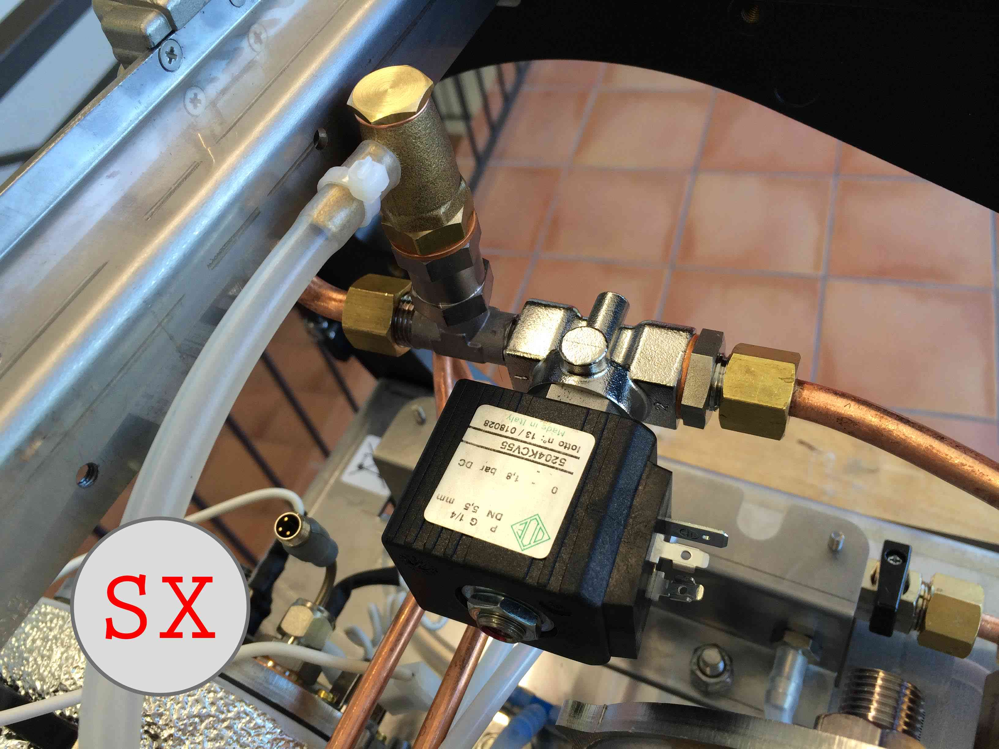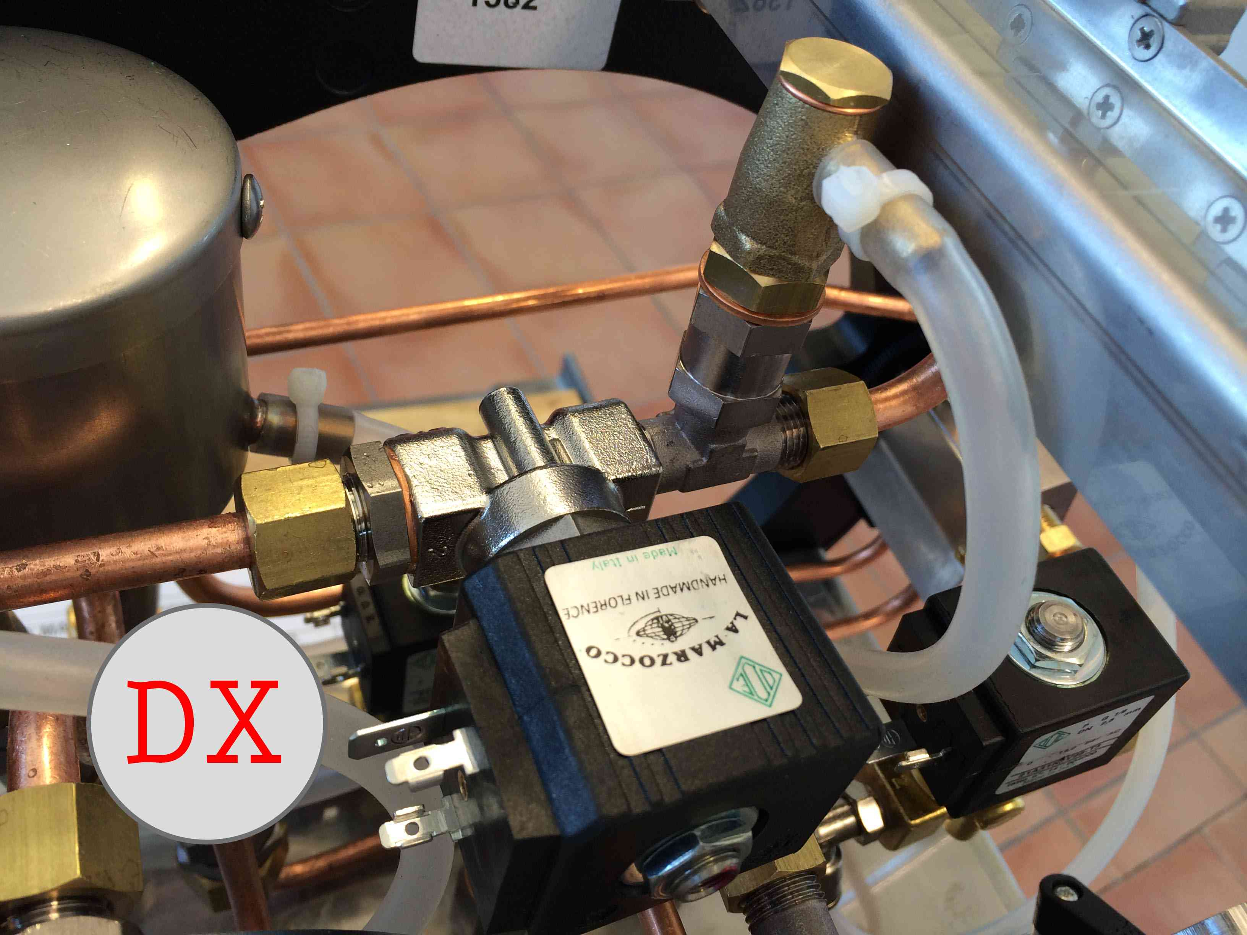

This device is standard on Strada EE models, and has been incorporated onto the Strada EP from serial number ST001369.

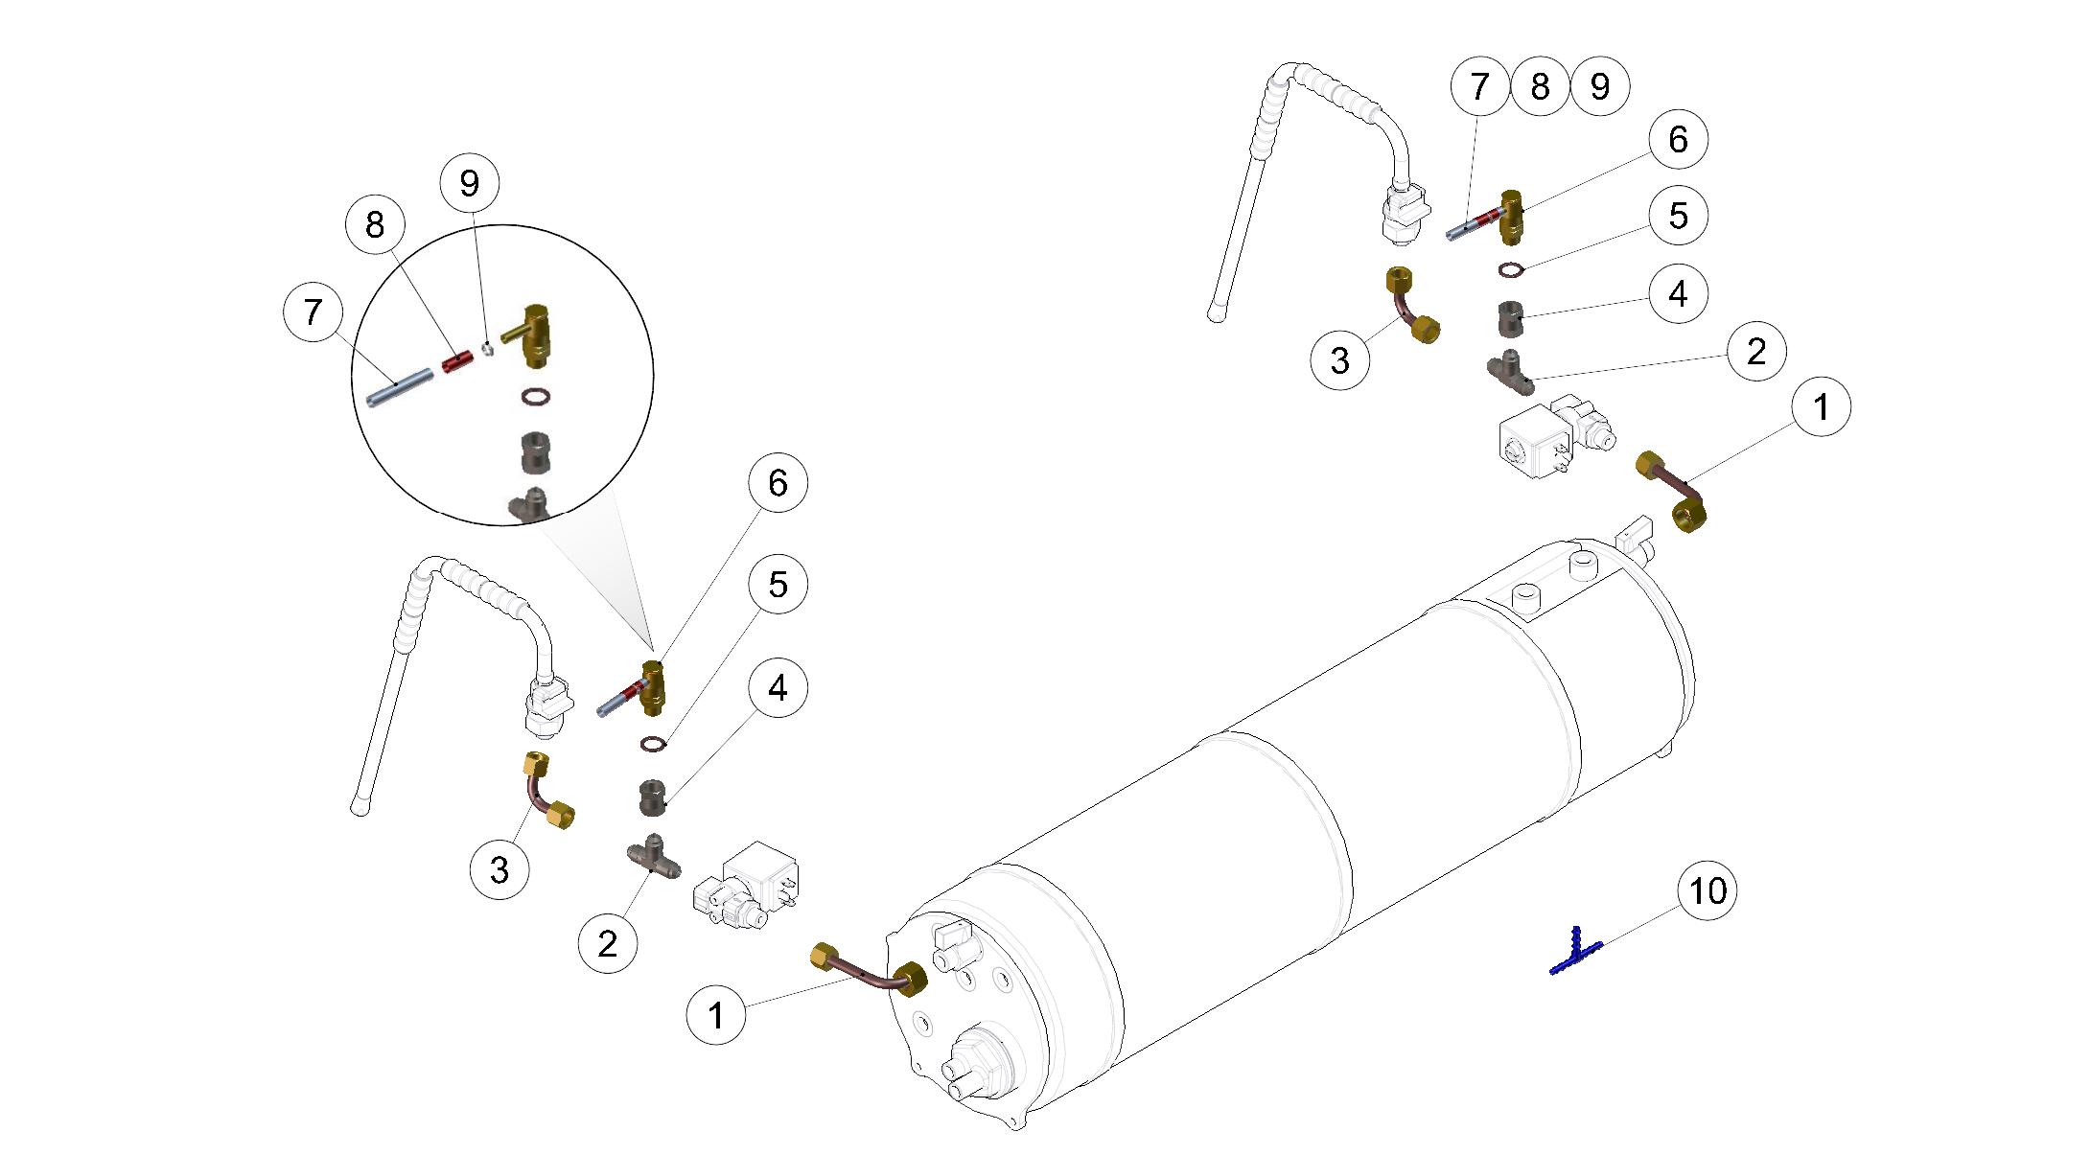

The kit will be supplied with a silicon hose for draining and T-fitting.
To retrofit an earlier Strada EP you can purchase the kit with this part number: 923 - STRADA EP ANTISUCTION KIT.

You can find all the instructions for the retrofit directly on our website
http://www.lamarzoccousa.com/wp-content/uploads/2014/07/HOW-TO-INSTALL-THE-ANTISUCTION-VALVE-ON-STRADA-EP.pdf

Please do not hesitate to contact us if you have any questions.

Best regards,
After Sales Department
Larry Eister Larry@lamarzoccousa.com
Scott Guglielmino Scott@lamarzoccousa.com
Support Team Support@lamarzoccousa.com

