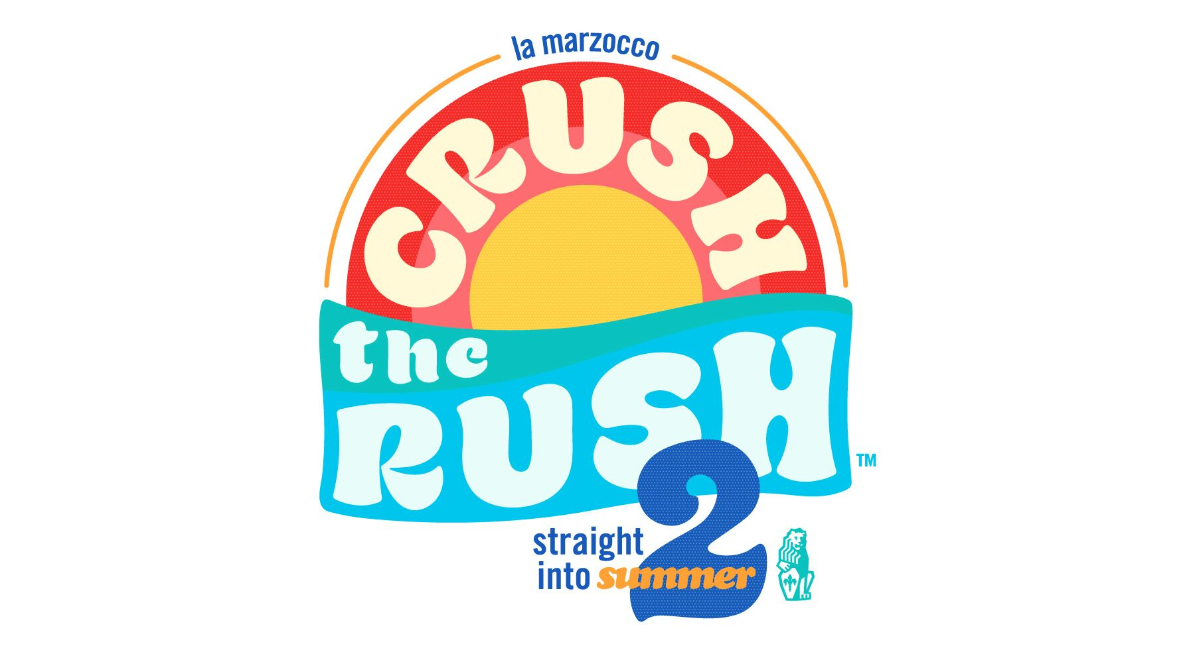

crush the rush 2 rules

about crush the rush 2

This summer, La Marzocco USA’s “Crush the Rush” will return for its second season. Eight Teams (with three baristas each) will compete head-to-head, racing to finish 8 espresso-based drinks in the fastest time. This competition is all about fun, speed, efficiency, and community.

20 teams will have the chance to compete throughout the day in the form of time trials, giving their best to complete a standardized line of drinks in the fastest amount of time. The 8 teams with the fastest qualifier times will advance to compete in the evening competition.

Throughout the main competition, teams will race to deliver 8 perfectly-made drinks to the judges’ table faster than their opponents. The fastest team from each heat will move on to the next round. In each round a new surprise will await the competitors to increase the difficulty. At the end of the night, one team will be awarded the soon-to-be legendary Crush the Rush trophy and $300.

Crush the Rush focuses on bar flow efficiency, technology, and fun! Teams will need to optimize their workflow, roles, and responsibilities in order to improve their speed. Each team will be competing on a La Marzocco KB90, with scales that will need to be programmed in order to maximize efficiency and accuracy.

Crush the Rush will be visiting 5 cities this summer. See the list below to see if we will be visiting your city. If you are interested in competing, register your team on the corresponding Eventbrite page. Teams consist of 3 persons per team and each city will be capped at 20 teams. Team registration will open two weeks prior to each event.

The final evening event is free and open to the public but space is limited. Your RSVP is requested on the corresponding Facebook Event Page. Please visit our Facebook pages to let us know you are coming.

team rules and roles

Rules

Teams are to be formed with 3 individuals, and must register on the corresponding La Marzocco Eventbrite page. If all team members are from the same company only one team may represent a company in each competition.

Roles

Barista - Shot-Packer: produces all espresso for beverages, may assist in steaming.
Milk Pony – Steamer: makes little horsey noises, etc.
Runner – Transporter: carries drinks (without spilling!) from the station to the judges table.

*These are suggested guidelines; teams may structure and assign roles however they like.

time trials

Drinks

This drink order will be the same for ALL cities. Coffee will be provided by the host coffee sponsor for qualifiers. All drinks will use provided whole milk.
1. Latte
2. Macchiato
3. Cappuccino
4. Cappuccino
5. Espresso
6. Cortado
7. Cappuccino
8. Latte
Teams will have a 30-minute block reserved for them on stage
10 minutes to familiarize themselves with the equipment and dial-in
10 minutes to complete the qualifier drink order
10 minutes to cleanup and reset their stations
-The stations will be at a distance of 3 meters from the judges table

Evaluation
Drinks and extractions will be evaluated to the same standard as the main competition rules.
Once all drinks have been completed and approved the judges will call “Time” and the team will receive their qualifier time for the day.
The teams with the top 8 times will be the ones invited to compete at the evening event.

competition finals

Dial-in: (8 minutes)
Each team will need to bring 5-pounds of coffee to be prepared as espresso.

Teams will have 8 minutes to dial-in their espresso, set-up their stations, program their machine and produce as shot for a technical judge that falls within competition parameters.
Teams may program their parameters into the machine using the Mass Mode controls during the competition or operate in the manual start/stop functionality.
Espresso must be dialed-in to meet the drink prep parameters below.

Drink Prep & Parameters:

1. Espresso doses must be within a 17-21 gram range (this will be measured visually as a “best guess”).
2. Espresso shots must be extracted within a 20-30 second period.
3. Espresso extraction output must fall within a 25-40 gram range.
4. All drinks are to be produced with “Double Shots” (A full extraction) from portafilters with splitters.

*Technical judges will monitor each espresso dosing, shot time and output weight during the competition.
If any shot falls outside the parameters, the Technical Judge blow a whistle, calling for a Remake.
For a remake, the team must discard that espresso extraction and produce another for drink preparation.

Drink Order and Presentation:

The same randomized drink order will be presented to both teams at the beginning of each heat.
Drinks must be presented in the order that they are assigned.
Only one drink may be presented to the judges at a time.
Only one member of each team may leave the station at a time to present the drink to the judges.
They must remain at the judging table until the pass/remake call has been made.

Judging Criteria:

The competitors’ performances will be evaluated by two types of judges: Visual and Technical. The panel will consist of 1 visual and 1 technical judge per team.

1. Technical Judge: The Technical judge will be ensuring that all of your shots fall within competition parameters.

2. Visual Judge: The Visual judge will be accessing your served drinks on:
Cleanliness, Foam Quality and Fill Level

Cleanliness: Drink vessels presented must be free of all spills or drips when present.

*Competitors may wipe any drips from the sides of cups with a towel before they are placed on the judging table. Once a drink is placed on the judging table it may not be touched.

Foam Quality: Milk foam must be created with a quality microfoam. Some form of Latte art is a requirement—that is, any shape (heart, etc.) may be poured as long as it shows a strong white-to-brown visual contrast.

Fill Level: All drinks must be filled to the top of their vessels within 5mm from the rim.

3. Competitors will present their completed drinks to the visual judges at the designated judging table. Each drink will have a designated and marked landing zone for placement.

4. Judges will vote “Pass” or “Remake” within 3 seconds of presentation.

Remake:

If a drink is required to be remade, it may be produced at any time during the competition time. The remade drink is to be placed in the appropriate landing zone for that drink.

Side work:

During the competition, we will introduce side work challenges described at the beginning of each round.
Any and as many members may leave the station to complete the side work at any time.

Last drink:

Once the last drink is placed, the judges will decide if it is a “pass,” and the runner will run back to the team’s station. Once they touch the station, they will have completed their round. The round is completed ONLY when all drinks have been given a “pass” and all 3 competitors are back at their station.

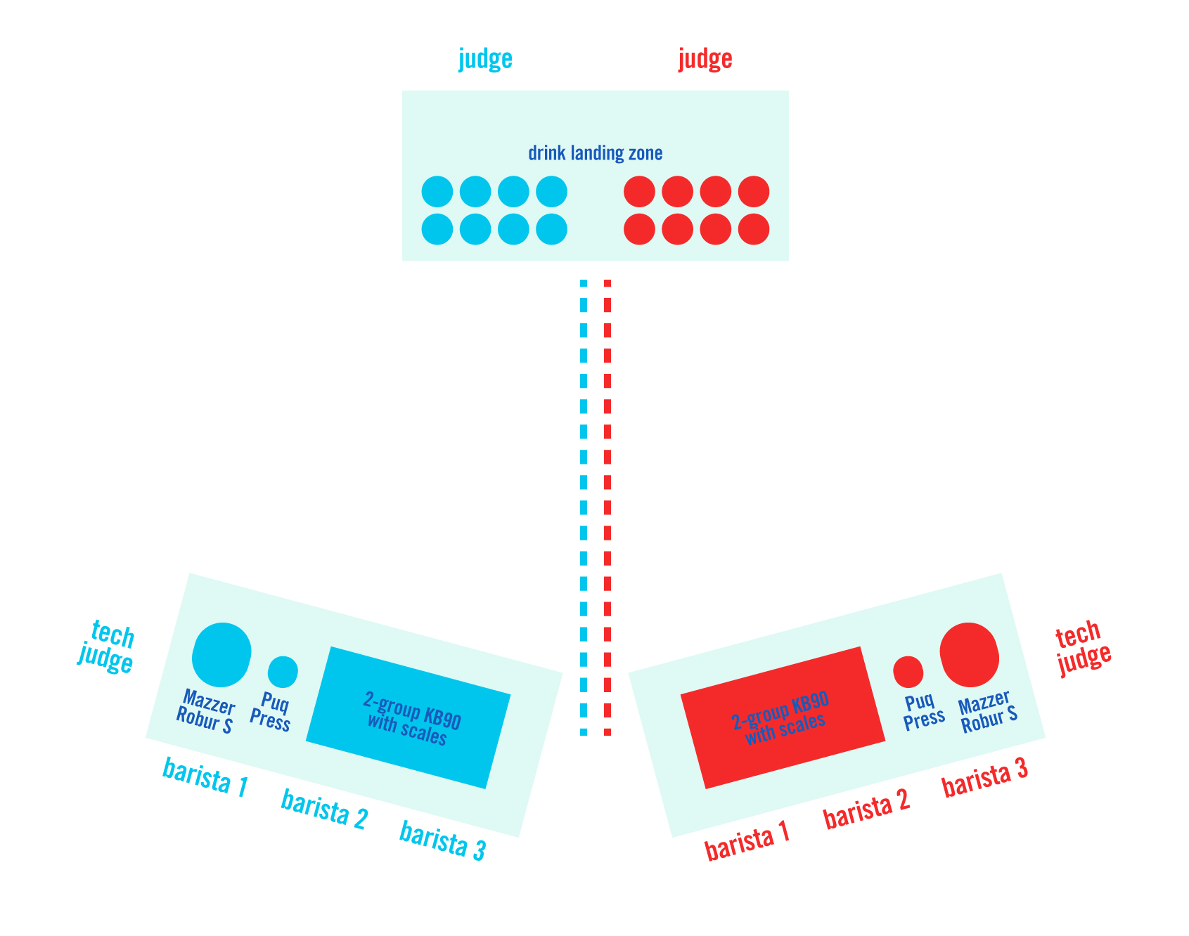

race layout

La Marzocco will provide each station with:
1 KB90 AV (2-group) with scales
1 Mazzer Robur S Grinder
1 Puqpress
1 Pitcher rinser
1 Milk cooler
1 Knock box
1 Tamper
1 Distribution Tool
2x 8oz pitchers
2x 12oz pitchers
1 Brush
Rags
All mugs & glassware
Bar rail shot vessel
*Team members are not permitted to bring their own equipment to the competition.
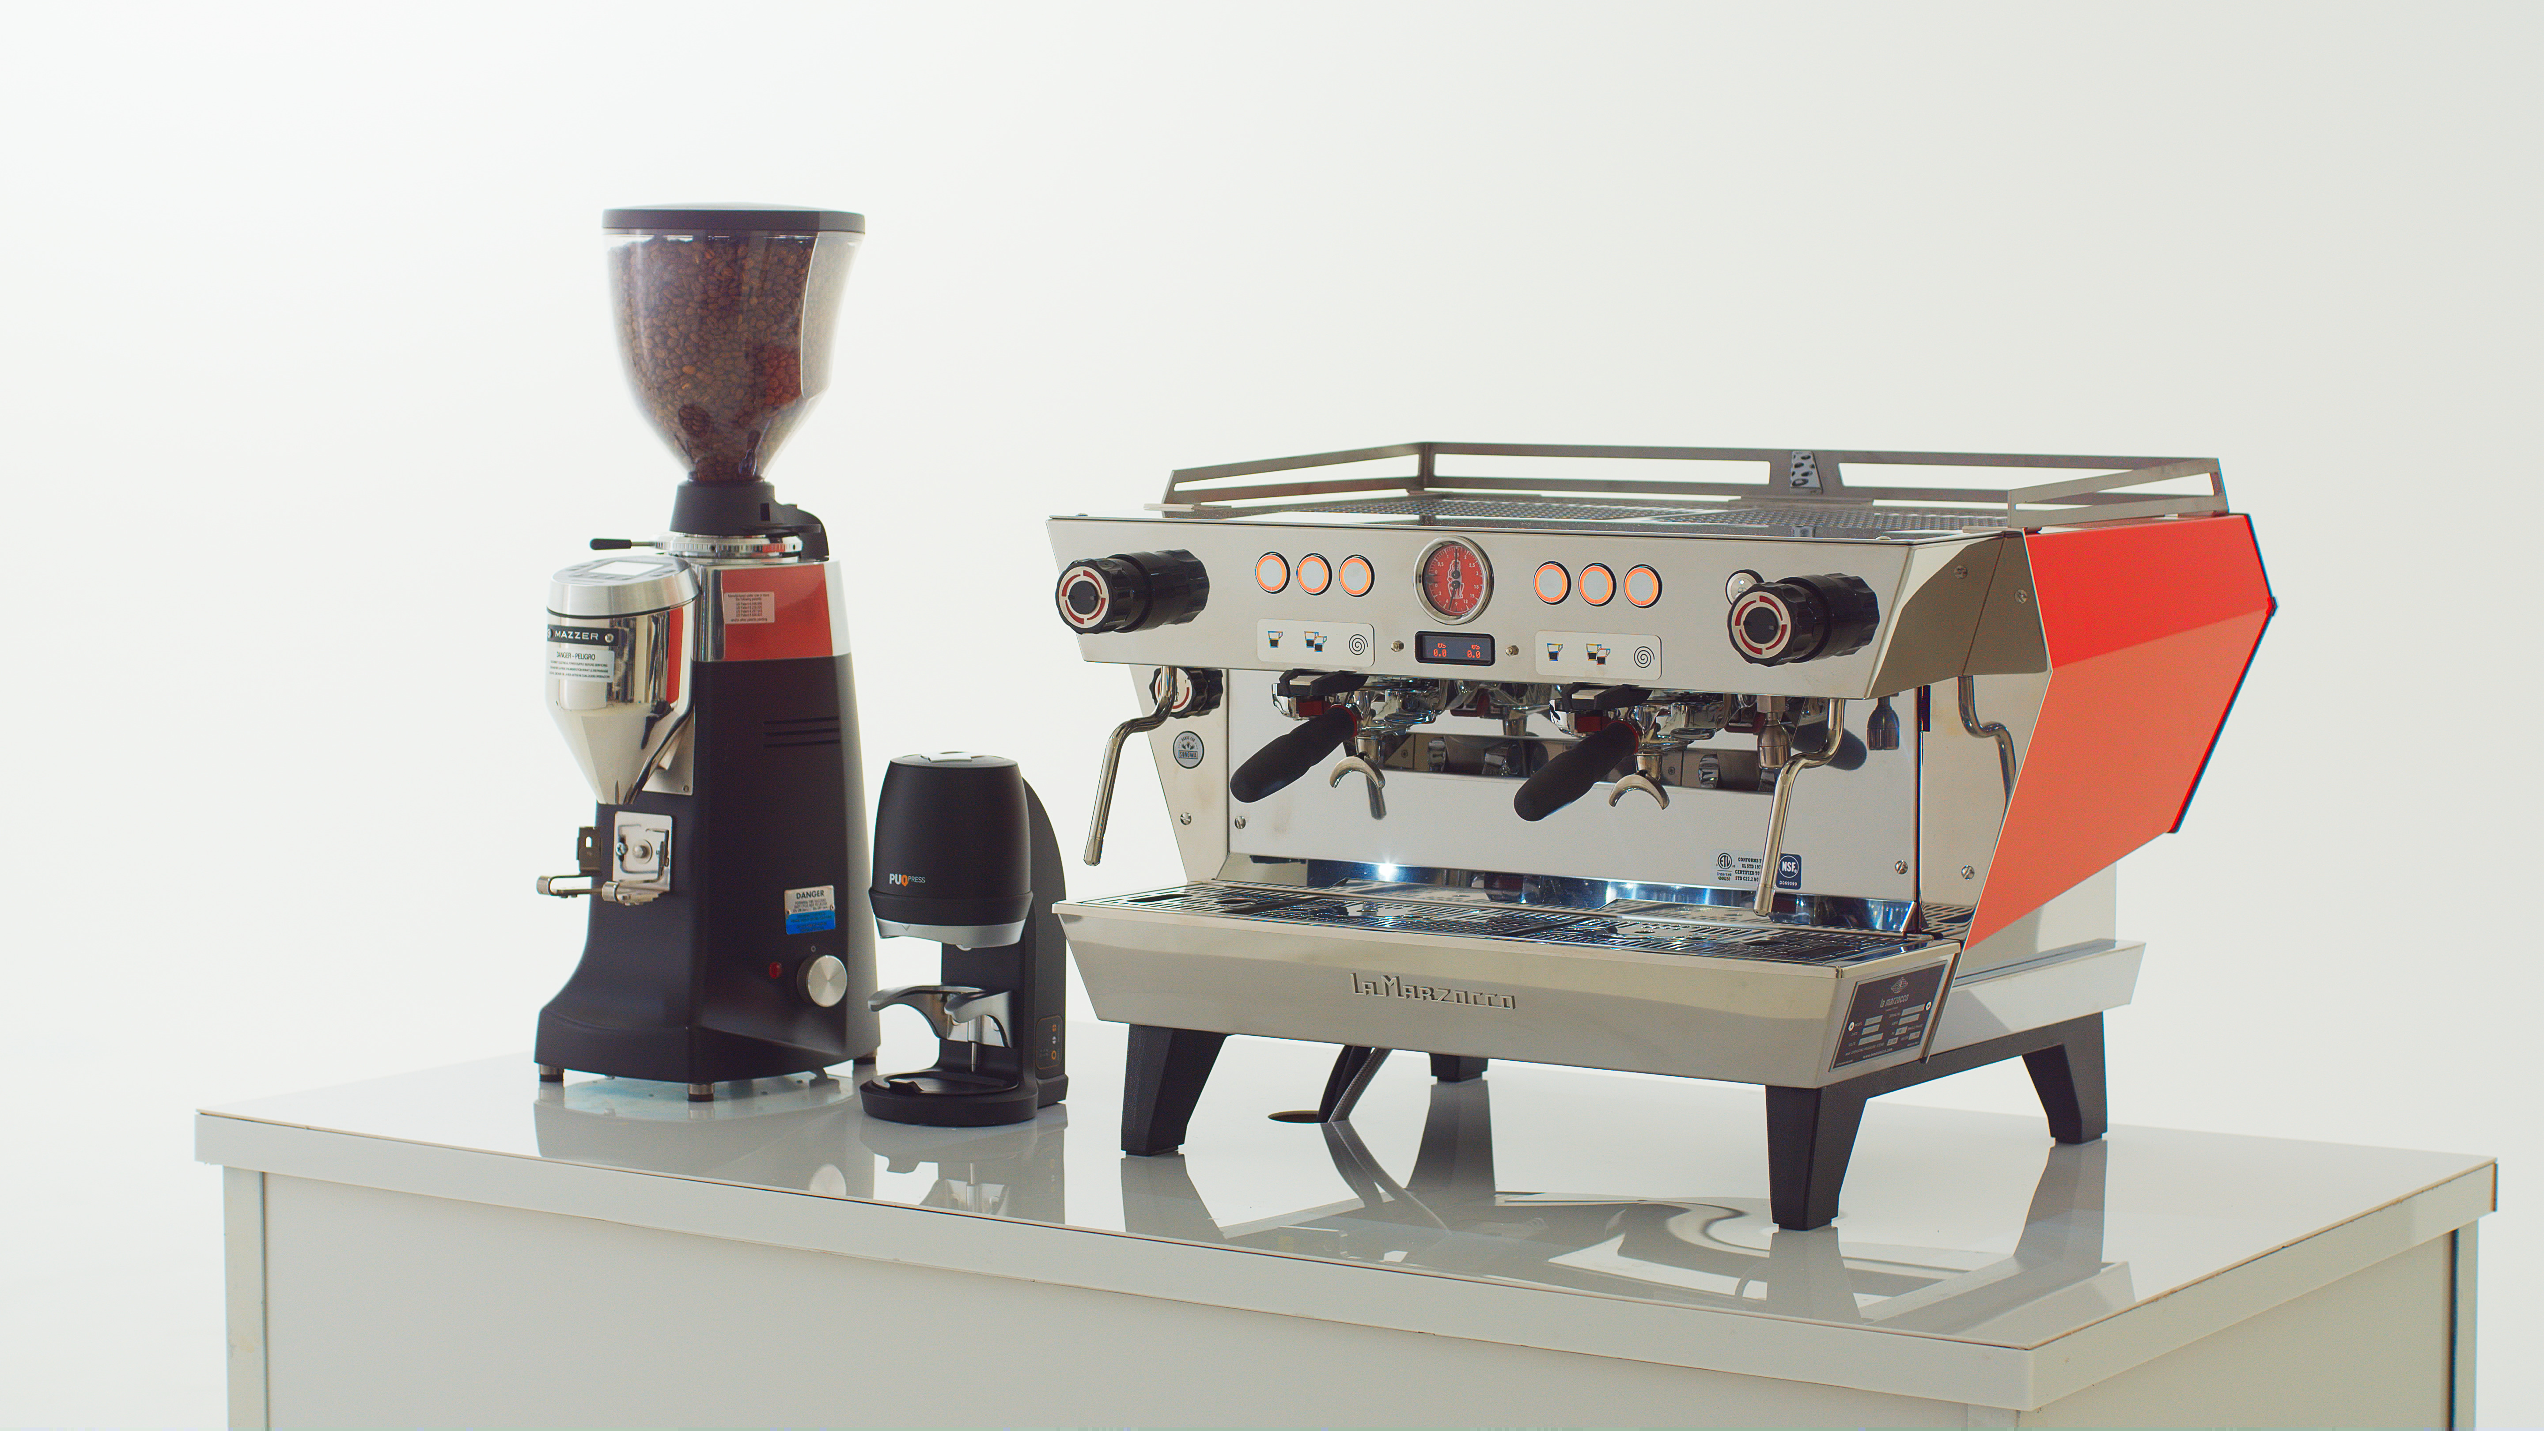
winners receive

A $300 cash prize, prizes from our partners, and the LEGENDARY Crush the Rush trophy.

